

**Project Report**

**On**

**Airline Ticket Reservation System**

(CSD 2206-5 DATABASE DESIGN AND SQL)

**Submitted to: Submitted by:**

Ms. Rachida Amjoun Lovepreet Kaur (C0763499)

Minh Phuong Ly (C0757038)

Aneesha Ann Aloysious (C0769743)

Honey Mathew (C0765178)

**CONTENTS**

INTRODUCTION 3

SQL Queries 4

1. Data entry into tables that you have created. 4

2. Travel history of a specific passenger. 8

3. Total hours that a specific aircraft has served during a specific time interval. 9

4. Total number of aircrafts belonging to a specific airline. 9

5. Total number of hours that a specific passenger has travelled during a specific time interval. 10

6. Total number of hours that a specific airline has been running during a specific time interval. 10

7. List of all passengers who flew to a specific city during a specific time interval. 11

8. Most visited city during the last month. 12

9. List of aircrafts that have **not** been in used from a specific source location. 12

10. List of airlines that run flight from a specific source to a destination. 13

11. The list of all options that a passenger can have when travelling from a source to a destination. This includes a connecting flight, for instance, a passenger is travelling from Toronto to Dehli and there is no direct flight, therefore, you have to find the options for this passenger. 14

12. What is the minimum number of hours that it will take for a passenger to travel from a source city to a destination city? Again, consider the connecting flights as mentioned in item number 9, e.g. travelling from Toronto to Dehli. 15

# INTRODUCTION

Airline Ticket Reservation System is a database project that facilitate the reservation of the online air tickets through an effective and yet simple GUI for a normal passenger intending to travel in airways. The project is basically targeted all those people who would like to travel through air. Apart from reserving tickets, through this system a passenger can compare fares ‘from’ various cities ‘to’ various cities.

# SQL Queries

1. Data entry into tables that you have created.

|  |
| --- |
| USE AIRWAY_BOOKING;  SELECT * FROM AIRCRAFT;  SELECT * FROM AIRLINE;  SELECT * FROM BOOKING;  SELECT * FROM FLIGHT;  SELECT * FROM GATE;  SELECT * FROM PASSENGER;  SELECT * FROM PASSENGER_INFO;  SELECT * FROM PAYMENT_ACCOUNT;  SELECT * FROM ROUTE;  SELECT * FROM ROUTE_GROUP;  SELECT * FROM ROUTE_GROUP_DETAIL;  SELECT * FROM TERMINAL;  SELECT * FROM TICKET; |

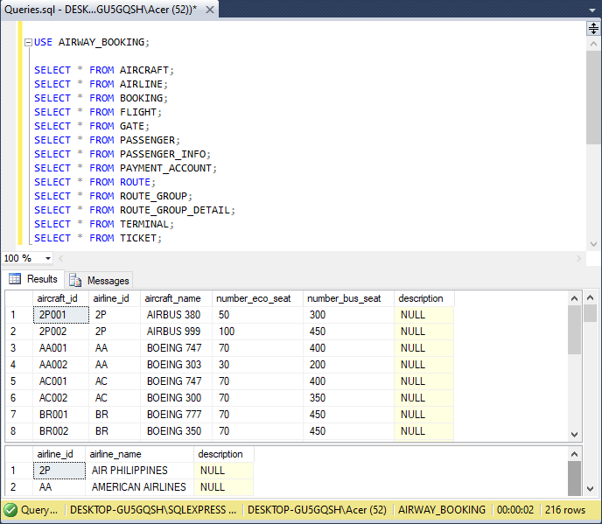

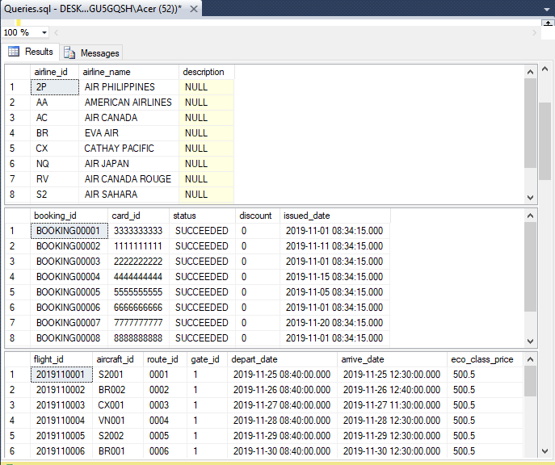

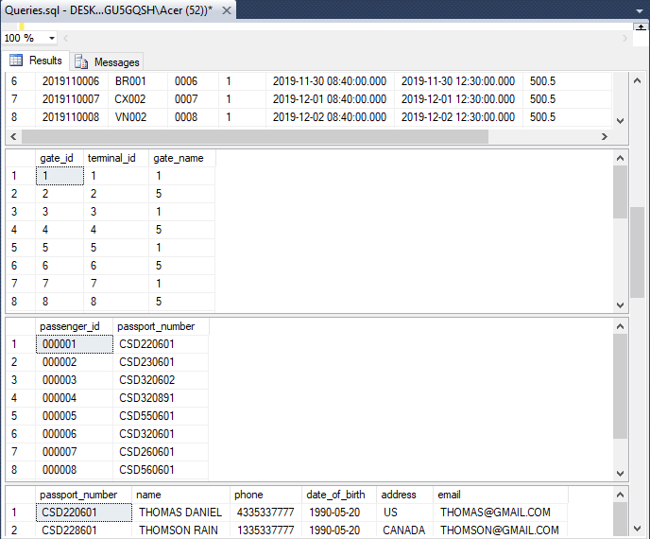

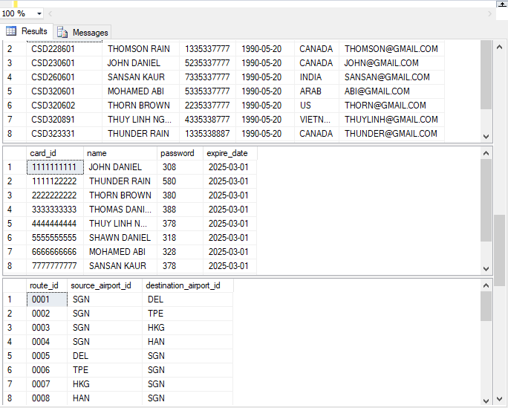

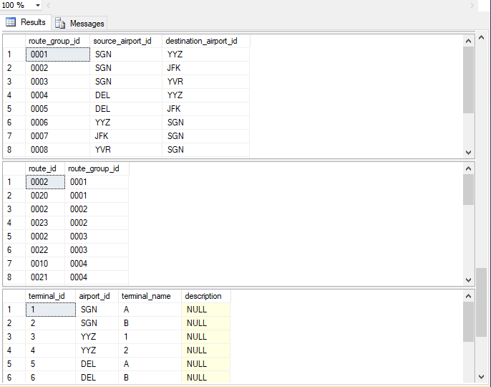

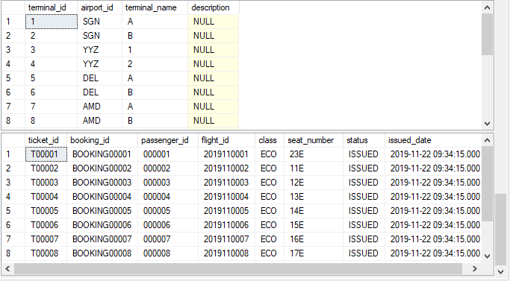

1. Travel history of a specific passenger.

|  |
| --- |
| USE AIRWAY_BOOKING;  /*Q2 Travel history of a specific passenger*/  /*Performing: All flights that passenger_id 000002 has flied*/  SELECT p.passenger_id, T.flight_id  FROM PASSENGER AS P INNER JOIN TICKET AS T ON P.passenger_id = T.passenger_id  INNER JOIN FLIGHT AS F ON T.flight_id = F.flight_id  WHERE p.passenger_id = '000002'; |

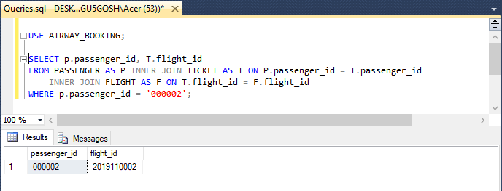

1. Total hours that a specific aircraft has served during a specific time interval.

|  |
| --- |
| USE AIRWAY_BOOKING;  /*Q3 total hours that a specific aircarft has served during a specific time interval*/  /*Performing: Total hours aircraft_if BR002 has served from Nov 26th 2019 to Dec 11th 2019*/  SELECT SUM(DATEDIFF(HH,depart_date,arrive_date)) AS 'Total Hours'  FROM FLIGHT  WHERE flight_id IN  (SELECT F.flight_id  FROM AIRCRAFT AS AC INNER JOIN FLIGHT AS F ON AC.aircraft_id = F.aircraft_id  WHERE (F.aircraft_id = 'BR002' AND F.depart_date BETWEEN '2019-11-26 00:00:00' AND '2019-12-11 00:00:00')); |

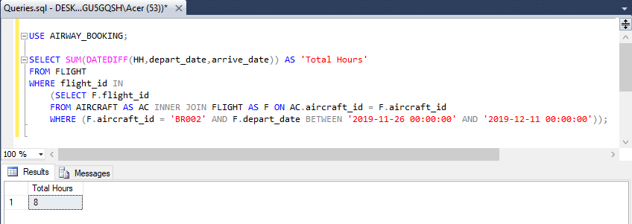

1. Total number of aircrafts belonging to a specific airline.

|  |
| --- |
| USE AIRWAY_BOOKING;  /*Q4 number of aircarfts belong to a specific airline*/  /*Performing: Total aircraft that Philipines Airline(2P) possessing*/  SELECT COUNT(aircraft_name) AS 'Total aircarfts'  FROM AIRCRAFT WHERE airline_id = '2P'; |

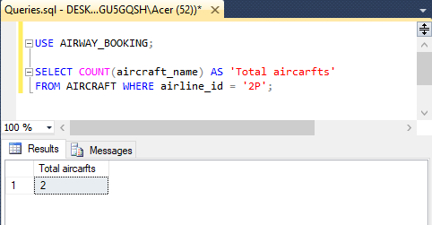

1. Total number of hours that a specific passenger has travelled during a specific time interval.

|  |
| --- |
| USE AIRWAY_BOOKING;  /*Q5 total hours that a specific passenger has travel during a specific time interval*/  /*Performing: Total hours passesger_if 000007 has traveled during the period of Nov 26th 219 - Dec 11th 2019*/  SELECT SUM(DATEDIFF(HH,depart_date,arrive_date)) AS 'Total Hours'  FROM FLIGHT  WHERE flight_id IN  (SELECT f.flight_id  FROM PASSENGER AS P INNER JOIN TICKET AS T ON P.passenger_id = T.passenger_id  INNER JOIN FLIGHT AS F ON T.flight_id = F.flight_id  WHERE (P.passenger_id = '000007' AND F.depart_date BETWEEN '2019-11-26 00:00:00' AND '2019-12-11 00:00:00')); |

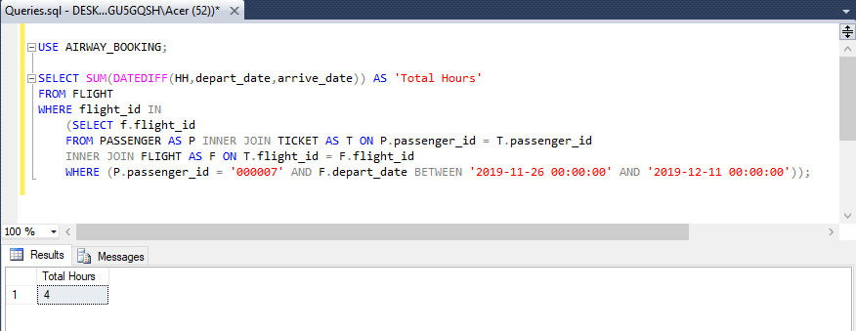

1. Total number of hours that a specific airline has been running during a specific time interval.

|  |
| --- |
| USE AIRWAY_BOOKING;  /*Q6 Total number of hours that a specific airline has been running during a specific time interval*/  /*Performing: Total number of hours that Eva Airline has been running between Nov 26 2019 and Dec 11 2019*/  SELECT SUM(DATEDIFF(HH,depart_date,arrive_date)) AS 'Total Hours'  FROM FLIGHT  WHERE flight_id IN (SELECT F.flight_id  FROM AIRCRAFT AS AC INNER JOIN AIRLINE AS AL  ON AC.airline_id = AL.airline_id  INNER JOIN FLIGHT AS F ON AC.aircraft_id = F.aircraft_id  WHERE AL.airline_id = 'BR' AND F.depart_date BETWEEN '2019-11-26 00:00:00'AND '2019-12-11 00:00:00'); |

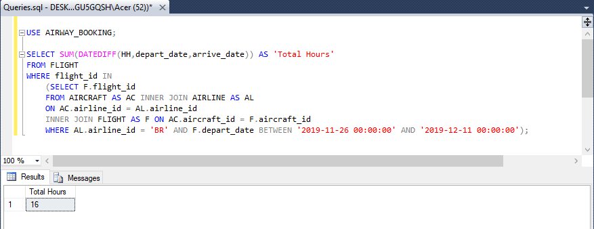

1. List of all passengers who flew to a specific city during a specific time interval.

|  |
| --- |
| USE AIRWAY_BOOKING;  /*Q7 List of all passengers who flew to a specific city during a specific time interval*/  /*Performing: List all passgener who flew to Hong Kong between Nov 26 2019 and Dec 11 2019*/  SELECT P.passenger_id, P_I.passport_number, P_I.name, P_I.phone, P_I.email, P_I.date_of_birth  FROM PASSENGER_INFO AS P_I INNER JOIN PASSENGER AS P ON P_I.passport_number = P.passport_number  WHERE P.passenger_id IN  (SELECT T.passenger_id FROM TICKET AS T INNER JOIN FLIGHT AS F ON T.flight_id = F.flight_id INNER JOIN ROUTE AS R ON F.route_id = R.route_id  INNER JOIN AIRPORT AS APD ON R.destination_airport_id = APD.airport_id  WHERE (APD.city = 'HONG KONG' AND F.arrive_date BETWEEN '2019-11-26 00:00:00' AND '2019-12-11 00:00:00')); |

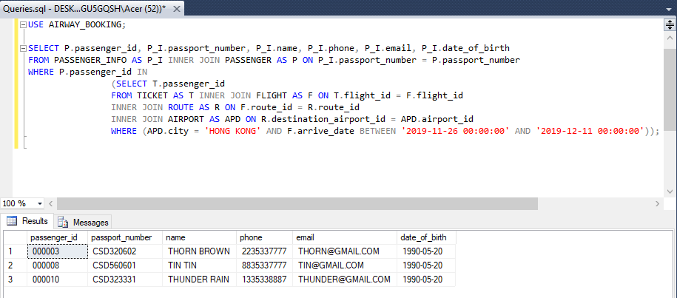

1. Most visited city during the last month.

|  |
| --- |
| USE AIRWAY_ BOOKING;  /*Q8 Most visited city during the last month.*/  /*Performing: Show the city was visited the most in the period from Nov 26 2019 to Dec 11 2019*/  SELECT TOP(1) *  FROM  (SELECT AP.city, COUNT(AP.city) AS 'Visited times'  FROM FLIGHT AS F INNER JOIN ROUTE AS R ON F.route_id = R.route_id  INNER JOIN AIRPORT AS AP ON R.destination_airport_id = AP.airport_id  WHERE F.arrive_date BETWEEN '2019-11-26 00:00:00' AND '2019-12-11 00:00:00'  GROUP BY AP.city) AS C  ORDER BY C.[Visited times] DESC; |

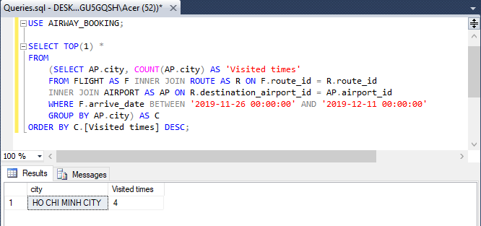

1. List of aircrafts that have **not** been in used from a specific source location.

|  |
| --- |
| USE AIRWAY_BOOKING;  SELECT DISTINCT aircraft_id FROM FLIGHT  WHERE route_id IN  (SELECT route_id FROM ROUTE WHERE source_airport_id != 'SGN'); |

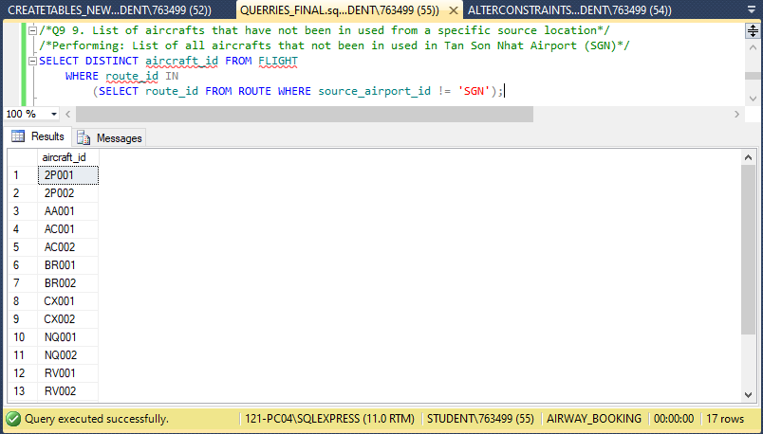

1. List of airlines that run flight from a specific source to a destination.

|  |
| --- |
| USE AIRWAY_BOOKING;  /*Q10 List of airlines that run flight from a specific source to a destination.*/  /*Performing: List of all airlines have the flight from DEL (Delhi City) to TPE (TAIWAN)*/  SELECT AL.airline_name  FROM AIRLINE AS AL INNER JOIN AIRCRAFT AS AC ON AL.airline_id = AC.airline_id  INNER JOIN FLIGHT AS F ON AC.aircraft_id = F.aircraft_id  WHERE F.flight_id IN  (SELECT flight_id  FROM FLIGHT  WHERE route_id =  (SELECT route_id FROM ROUTE  WHERE source_airport_id = 'DEL' AND destination_airport_id = 'TPE')); |

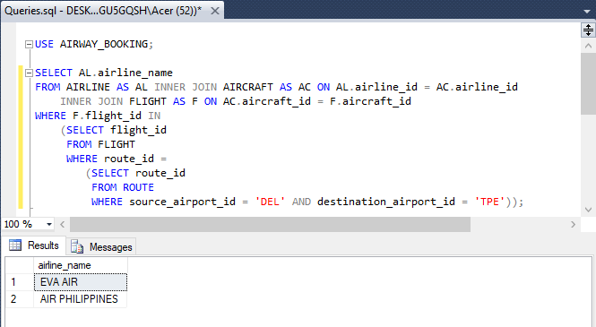

1. The list of all options that a passenger can have when travelling from a source to a destination. This includes a connecting flight, for instance, a passenger is travelling from Toronto to Dehli and there is no direct flight, therefore, you have to find the options for this passenger.

|  |
| --- |
| USE AIRWAY_BOOKING;  /*Q11 The list of all options that a passenger can have when travelling from a source to a destination.  This includes a connecting flight, for instance, a passenger is travelling from Toronto to Dehli and there is no  direct flight, therefore, you have to find the options for this passenger.*/  /*Performing: List all in-direct flights from SGN(Ho Chi Minh City) to YYZ(Toronto)*/  SELECT RGD.route_group_id,F.flight_id, F.route_id, AP1.city AS 'Depart', AP2.city AS 'Arrive', f.depart_date, f.arrive_date  FROM FLIGHT AS F INNER JOIN ROUTE AS R ON F.route_id = R.route_id  INNER JOIN AIRPORT AS AP1 ON R.source_airport_id = AP1.airport_id  INNER JOIN AIRPORT AS AP2 ON R.destination_airport_id = AP2.airport_id  INNER JOIN ROUTE_GROUP_DETAIL AS RGD ON R.route_id = RGD.route_id  WHERE RGD.route_group_id IN  (SELECT route_group_id  FROM ROUTE_GROUP  WHERE source_airport_id = 'SGN' AND destination_airport_id = 'YYZ')  ORDER BY RGD.route_group_id, F.depart_date; |

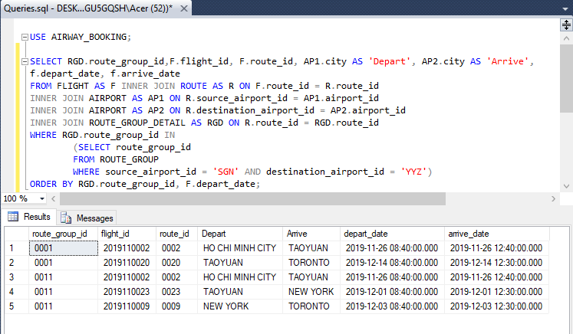

1. What is the minimum number of hours that it will take for a passenger to travel from a source city to a destination city? Again, consider the connecting flights as mentioned in item number 9, e.g. travelling from Toronto to Dehli.

|  |
| --- |
| USE AIRWAY_BOOKING;  /*Q12 What is the minimum number of hours that it will take for a passenger to travel from a source city to a  destination city. Again, consider the connecting flights as mentioned in item number 9, e.g. travelling from Toronto to Dehli.*/  /*Performing: Amount of minimum hour it takes for flying from SGN to YYZ*/  SELECT MIN(B.Total_hours) AS 'Minimum number of hours' FROM  (SELECT STR(CAST(SUM(DATEDIFF(MINUTE,C.depart_date,C.arrive_date)) AS DECIMAL(10,2))/60,10,2) AS 'Total_hours'  FROM  (SELECT RGD.route_group_id,F.flight_id, F.route_id, F.arrive_date, F.depart_date  FROM FLIGHT AS F INNER JOIN ROUTE AS R ON F.route_id = R.route_id  INNER JOIN AIRPORT AS AP1 ON R.source_airport_id = AP1.airport_id  INNER JOIN AIRPORT AS AP2 ON R.destination_airport_id = AP2.airport_id  INNER JOIN ROUTE_GROUP_DETAIL AS RGD ON R.route_id = RGD.route_id  WHERE RGD.route_group_id IN  (SELECT route_group_id  FROM ROUTE_GROUP  WHERE source_airport_id = 'SGN' AND destination_airport_id = 'YYZ')) AS C  GROUP BY C.route_group_id) AS B; |

